CHAPTER I
PROBLEM STATEMENT

1.1 Problem Statement
India is one of the most biologically diverse regions in the world and hosts more than 1,300 species of birds distributed across forests, wetlands, grasslands, urban ecosystems, and coastal regions. Bird species identification plays a crucial role in ecological research, wildlife conservation, environmental monitoring, and educational activities. Traditionally, bird identification relies on expert ornithologists, field guides, and manual observation of physical characteristics such as plumage color, beak shape, wing patterns, and habitat behavior. This manual process is time-consuming, error-prone, and inaccessible to beginners or non-experts.
With the rapid growth of digital photography and mobile devices, vast numbers of bird images are captured daily by bird watchers, students, and researchers. However, converting these images into accurate species information remains a major challenge due to variations in lighting, pose, occlusion, background clutter, and image quality. Many existing applications provide limited accuracy or support only a small number of species. Furthermore, offline accessibility, dataset scalability, and model generalization remain significant challenges.
The Indian Birds Classifier project aims to solve these issues by developing a deep learning-based automated bird species identification system. The system accepts an image of a bird and predicts the corresponding species using a trained convolutional neural network model. The model is trained on an Indian bird dataset and optimized for high accuracy, robustness, and usability. This project helps researchers, students, wildlife enthusiasts, and conservationists quickly identify bird species without expert knowledge.
The objectives of the system are:
- To automate bird species identification using deep learning.
- To improve classification accuracy for Indian bird species.
- To provide a simple and user-friendly interface.
- To enable fast and reliable predictions.
- To support scalability for adding new bird classes in the future.
This system bridges the gap between biodiversity knowledge and artificial intelligence by enabling real-time species recognition.

CHAPTER II
SYSTEM STUDY
2.1 Existing System
The traditional bird identification process depends heavily on:
- Printed field guides and manuals.
- Expert consultation.
- Manual observation.
- Manual comparison of physical features.
While effective for experts, this approach has multiple limitations:
- Requires domain expertise.
- Time-consuming process.
- Prone to human error.
- Difficult for beginners.
- Limited scalability.
- Not suitable for real-time usage.
Some mobile applications and web platforms exist, but they often:
- Support only limited species.
- Require constant internet connectivity.
- Have low accuracy in complex images.
- Struggle with background noise and occlusion.
- Do not focus specifically on Indian biodiversity.

2.2 Proposed System
The proposed system uses deep learning techniques to automatically classify bird species from images. The system integrates:
- Image preprocessing
- Convolutional Neural Networks (CNN)
- Transfer Learning models
- Model evaluation and optimization
- User-friendly prediction interface
Key features include:
- Automated image classification.
- High accuracy prediction.
- Scalable dataset architecture.
- Offline model execution.
- Fast inference.
- Support for multiple species.

2.3 Tools and Technologies Used
Hardware Requirements
- Processor: Intel i5 / Ryzen 5 or higher
- RAM: Minimum 8GB
- GPU: NVIDIA GPU (optional for training)
- Storage: Minimum 20GB
Software Requirements
- Python 3.x
- TensorFlow / Keras
- NumPy
- OpenCV
- Matplotlib
- Scikit-learn
- Kaggle GPU Environment
- GitHub for version control
Development Environment
- Jupyter Notebook / VS Code
- Kaggle Notebook

CHAPTER III
SYSTEM DESIGN
3.1 System Architecture Diagram
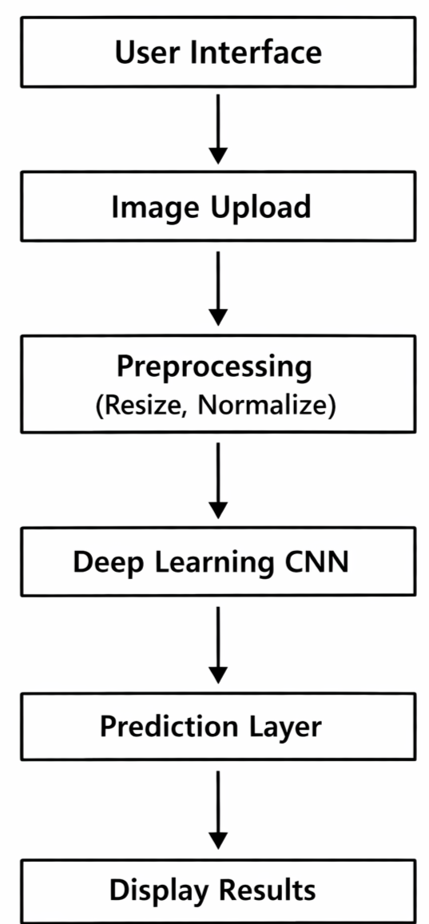
A system architecture diagram visually represents the overall structure and workflow of the application. It shows how different modules such as image upload, preprocessing, deep learning model, and prediction are interconnected. This diagram helps in understanding the data flow and functional relationship between each component. It also provides a clear overview of how the system processes input and generates output.

3.2 Use Case Diagram
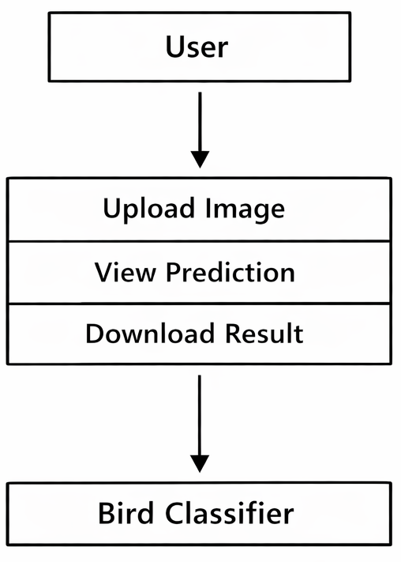
A use case diagram illustrates the interaction between the user and the system to achieve specific tasks. It highlights the main functionalities such as uploading images, viewing predictions, and downloading results. This diagram helps in identifying user requirements and system behavior in a simple visual form. It ensures clarity in system functionality and user interaction flow.

3.3 Data Flow Diagram (DFD)
The data flow diagram represents how information moves through the system from input to output. The user uploads an image, which is passed to the deep learning model for processing and analysis. The model generates a prediction based on the learned patterns from the dataset.
Finally, the predicted result is returned to the user for viewing and decision-making.
Data Flow Diagram (DFD) :
The 0-level DFD of the system :
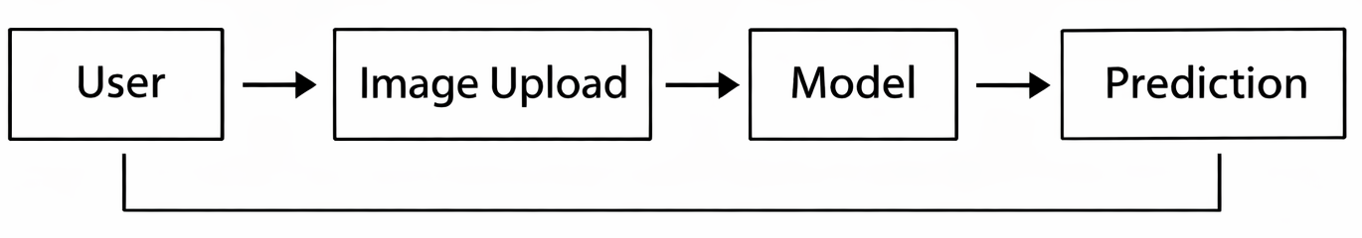
The 1-level DFD of the system :

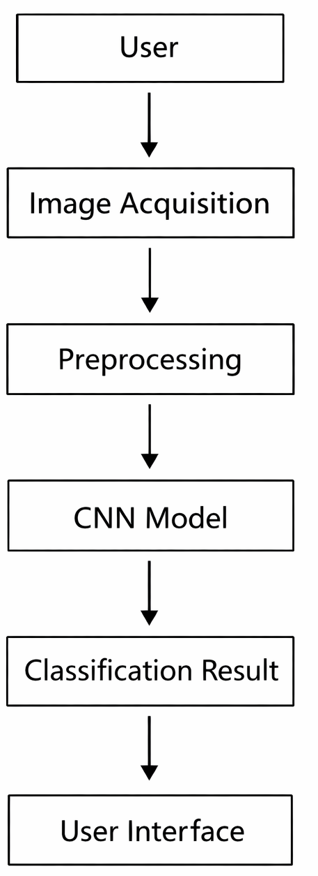

3.4 State Diagram
This flowchart illustrates the complete execution flow of the image classification system.
The process starts with the user uploading an image, followed by preprocessing to prepare the image for analysis. The trained model performs prediction based on the processed image data.
Finally, the result is displayed to the user and the process ends.

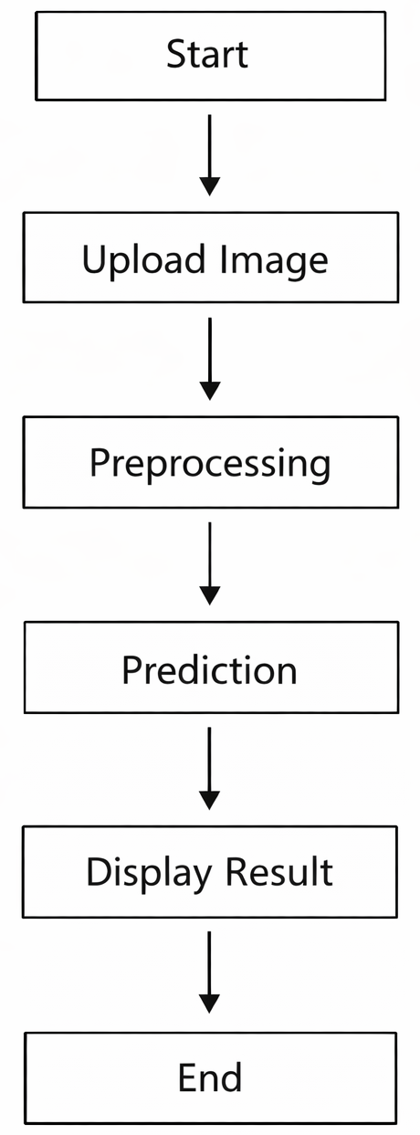

CHAPTER IV
MODULE DESCRIPTION
The Indian Birds Classifier system is designed using a modular architecture approach. Each module performs a well-defined function and interacts smoothly with other modules to ensure reliable performance, scalability, and maintainability. This structured design simplifies development, testing, debugging, and future enhancements. The major modules of the system are Dataset Management Module, Image Preprocessing Module, Model Training Module, Model Evaluation Module, and Prediction and User Interface Module.
4.1 Dataset Management Module
The Dataset Management Module is responsible for handling the collection, organization, validation, and preparation of bird image datasets used for training and testing the deep learning model. The dataset consists of multiple bird species images categorized into separate folders, where each folder represents a unique class label. This structured format allows the training pipeline to automatically read and label images during training.
This module ensures dataset integrity by verifying image formats, checking for corrupted files, and maintaining consistency in image resolution and file naming conventions. Data balancing techniques are also applied to prevent class imbalance issues that could bias the learning process. If a particular bird species contains fewer samples, augmentation techniques are used to artificially increase the dataset size while maintaining diversity.
The module also splits the dataset into training, validation, and testing sets. The training set is used to learn model parameters, the validation set helps tune hyperparameters and prevent overfitting, and the testing set evaluates the final model performance. Proper dataset management ensures that the model generalizes well to unseen images and reduces the risk of data leakage.
4.2 Image Preprocessing Module
The Image Preprocessing Module transforms raw input images into a standardized format suitable for neural network training and prediction. Since bird images are captured in varying lighting conditions, resolutions, orientations, and backgrounds, preprocessing is essential for improving model accuracy and stability.
This module performs image resizing to match the input dimensions expected by the neural network. Pixel normalization scales image values to a fixed range, improving numerical stability during training. Noise reduction techniques remove irrelevant artifacts from the image that could negatively affect feature extraction. Color normalization ensures consistency across images captured using different cameras or lighting environments.
Data augmentation is also part of preprocessing and includes operations such as horizontal flipping, rotation, zooming, brightness adjustment, and random cropping. These transformations increase dataset diversity and help the model learn invariant features, reducing overfitting and improving robustness. The preprocessing pipeline ensures that all images are uniformly prepared before being passed to the neural network.

4.3 Model Training Module
The Model Training Module is the core component of the system. It builds and trains the deep learning architecture responsible for extracting features and performing classification. The system employs Convolutional Neural Networks (CNNs) and transfer learning models such as EfficientNet, DenseNet, or ResNet to leverage pre-trained knowledge from large-scale image datasets.
This module defines the network architecture, activation functions, optimizer selection, learning rate scheduling, and loss function configuration. During training, the model learns hierarchical features such as edges, textures, shapes, and complex patterns specific to bird species. Batch processing improves computational efficiency, and GPU acceleration speeds up the training process.
Training callbacks such as early stopping, model checkpointing, and learning rate reduction are used to prevent overfitting and maintain optimal performance. The model weights are saved periodically to enable recovery and experimentation. Hyperparameter tuning is performed to achieve the best balance between accuracy and generalization.
4.4 Model Evaluation Module
The Model Evaluation Module measures the performance and reliability of the trained model using quantitative metrics. Accuracy provides a general measure of correct predictions, while precision, recall, and F1-score analyze classification quality at the class level. Confusion matrices visualize misclassification patterns and identify problematic classes.
Validation loss curves and training accuracy graphs help detect overfitting or underfitting issues. The module also supports cross-validation and testing on unseen data to assess real-world performance. Evaluation results guide further model tuning and optimization. This systematic evaluation ensures that the system meets reliability and quality expectations before deployment.
4.5 Prediction and User Interface Module
The Prediction Module loads the trained model and performs inference on user-provided images. Uploaded images undergo preprocessing and are passed through the neural network for prediction. The system outputs the predicted bird species along with confidence scores.
The User Interface Module enables easy interaction with the system by allowing users to upload images and view classification results. Error handling mechanisms notify users if invalid or unsupported files are uploaded. The interface emphasizes simplicity, accessibility, and responsiveness. This module bridges the technical model and end-user usability, ensuring a seamless experience.

CHAPTER V
SOFTWARE TESTING
Software testing is essential to ensure the correctness, reliability, performance, and usability of the Indian Birds Classifier system. The testing process validates every module independently and collectively to ensure seamless integration and error-free execution.
5.1 Functional Testing
Functional testing verifies that each feature of the system operates as expected. Image upload functionality is tested with various formats, resolutions, and sizes. The preprocessing pipeline is validated to ensure correct resizing, normalization, and augmentation. Prediction outputs are verified against known labels to confirm accuracy.
Error scenarios such as unsupported file types, missing images, and corrupted inputs are tested to ensure proper exception handling and user-friendly error messages.
5.2 Performance Testing
Performance testing evaluates system responsiveness and computational efficiency. Model inference time is measured to ensure predictions are generated quickly. Memory usage and GPU utilization are monitored during training and inference. Stress testing evaluates performance under heavy workloads or batch processing conditions.
5.3 Accuracy and Validation Testing
Accuracy testing ensures that the model consistently achieves acceptable prediction performance. Metrics such as accuracy, precision, recall, and F1-score are computed on validation and test datasets. Confusion matrix analysis identifies class-level weaknesses and guides improvements.
5.4 Usability Testing
Usability testing focuses on ease of use, interface clarity, navigation flow, and accessibility. User feedback is collected to refine layout design and interaction simplicity. The system ensures minimal learning curve for beginners and researchers alike.
5.5 Security and Reliability Testing
Security testing validates input sanitization and prevents malicious file uploads. Reliability testing ensures that the system operates continuously without crashes or memory leaks. Backup mechanisms ensure model safety and reproducibility.

CHAPTER VI
CONCLUSION
The Indian Birds Classifier project successfully demonstrates the application of deep learning techniques for automated bird species identification. The system effectively integrates dataset processing, image preprocessing, neural network training, evaluation, and user interaction into a unified framework. By leveraging transfer learning and convolutional neural networks, the system achieves high classification accuracy while maintaining computational efficiency.
The modular architecture enables scalability and flexibility, allowing new bird species to be added without restructuring the entire system. The project contributes toward wildlife conservation, educational research, biodiversity monitoring, and citizen science initiatives. Automated species identification reduces dependency on expert knowledge and accelerates data collection and analysis.
The project also highlights the importance of data quality, preprocessing techniques, and model optimization in achieving reliable results. The successful implementation validates the feasibility of AI-driven ecological applications and opens pathways for advanced research and commercialization.
FUTURE ENHANCEMENTS
The future scope of the Indian Birds Classifier project is vast and promising. Additional bird species can be incorporated to expand classification coverage. Mobile and web application deployment can enable real-time predictions using smartphones. Cloud integration can support scalable processing and global accessibility.
Advanced features such as real-time video detection, bird call audio recognition, and GPS-based habitat mapping can further enhance system intelligence. Integration with conservation databases can support ecological research and population tracking. Continuous model training using user-submitted images can improve accuracy and adaptability.
Artificial intelligence advancements such as self-supervised learning, edge computing, and federated learning can further optimize performance and privacy. The system has strong potential for commercialization, educational platforms, and environmental sustainability projects.

CHAPTER VII
APPENDIX
7.1 SAMPLE CODE
import os
import cv2
import numpy as np
import tensorflow as tf
from tensorflow import keras
from tensorflow.keras import layers
from tensorflow.keras.models import Sequential
from tensorflow.keras.applications import EfficientNetB0
from tensorflow.keras.callbacks import EarlyStopping, ModelCheckpoint
from sklearn.model_selection import train_test_split
from sklearn.preprocessing import LabelEncoder
from sklearn.metrics import classification_report, confusion_matrix
import matplotlib.pyplot as plt

# -----------------------------
# CONFIGURATION
# -----------------------------
IMG_SIZE = 224
BATCH_SIZE = 16
EPOCHS = 30
DATASET_PATH = "dataset/"
MODEL_SAVE_PATH = "models/bird_classifier.h5"

# -----------------------------
# LOAD DATASET
# -----------------------------
images = []
labels = []

for class_name in os.listdir(DATASET_PATH):
class_path = os.path.join(DATASET_PATH, class_name)
if not os.path.isdir(class_path):
continue

for img_name in os.listdir(class_path):
img_path = os.path.join(class_path, img_name)

try:
img = cv2.imread(img_path)
img = cv2.resize(img, (IMG_SIZE, IMG_SIZE))
images.append(img)
labels.append(class_name)
except:
print("Error loading:", img_path)

images = np.array(images, dtype="float32") / 255.0
labels = np.array(labels)

# -----------------------------
# LABEL ENCODING
# -----------------------------
encoder = LabelEncoder()
labels_encoded = encoder.fit_transform(labels)
labels_encoded = keras.utils.to_categorical(labels_encoded)

# -----------------------------
# TRAIN TEST SPLIT
# -----------------------------
X_train, X_test, y_train, y_test = train_test_split(
images, labels_encoded, test_size=0.2, random_state=42
)

# -----------------------------
# MODEL ARCHITECTURE
# -----------------------------
base_model = EfficientNetB0(
include_top=False,
weights="imagenet",
input_shape=(IMG_SIZE, IMG_SIZE, 3)
)

base_model.trainable = False

model = Sequential([
base_model,
layers.GlobalAveragePooling2D(),
layers.Dense(256, activation="relu"),
layers.Dropout(0.5),
layers.Dense(len(np.unique(labels)), activation="softmax")
])

model.compile(
optimizer="adam",
loss="categorical_crossentropy",
metrics=["accuracy"]
)

model.summary()

# -----------------------------
# CALLBACKS
# -----------------------------
checkpoint = ModelCheckpoint(
MODEL_SAVE_PATH,
monitor="val_accuracy",
save_best_only=True,
verbose=1
)

earlystop = EarlyStopping(
monitor="val_loss",
patience=5,
restore_best_weights=True
)

# -----------------------------
# TRAIN MODEL
# -----------------------------
history = model.fit(
X_train,
y_train,
validation_data=(X_test, y_test),
epochs=EPOCHS,
batch_size=BATCH_SIZE,
callbacks=[checkpoint, earlystop]
)

# -----------------------------
# SAVE MODEL
# -----------------------------
model.save(MODEL_SAVE_PATH)

# -----------------------------
# EVALUATION
# -----------------------------
y_pred = model.predict(X_test)
y_pred_classes = np.argmax(y_pred, axis=1)
y_true = np.argmax(y_test, axis=1)

print(classification_report(y_true, y_pred_classes))

cm = confusion_matrix(y_true, y_pred_classes)
print(cm)

# -----------------------------
# PLOT ACCURACY
# -----------------------------
plt.plot(history.history["accuracy"], label="Train Accuracy")
plt.plot(history.history["val_accuracy"], label="Validation Accuracy")
plt.legend()
plt.show()
import cv2
import numpy as np

IMG_SIZE = 224

def preprocess_image(image_path):
image = cv2.imread(image_path)
image = cv2.resize(image, (IMG_SIZE, IMG_SIZE))
image = image / 255.0
image = np.expand_dims(image, axis=0)
return image

def augment_image(image):
flip = cv2.flip(image, 1)
blur = cv2.GaussianBlur(image, (5,5), 0)
return flip, blur
import numpy as np
import cv2
from tensorflow.keras.models import load_model
from preprocess import preprocess_image

MODEL_PATH = "models/bird_classifier.h5"
CLASS_NAMES = [
"Asian Green Bee Eater",
"Cattle Egret",
"Indian Roller",
"Peacock",
"Common Myna",
"Hoopoe"
]

model = load_model(MODEL_PATH)

def predict_image(image_path):
img = preprocess_image(image_path)
prediction = model.predict(img)
class_index = np.argmax(prediction)
confidence = np.max(prediction) * 100
return CLASS_NAMES[class_index], confidence

if __name__ == "__main__":
image_path = "test.jpg"
label, confidence = predict_image(image_path)
print("Predicted Bird:", label)
print("Confidence:", confidence)
import os
import cv2
import numpy as np

IMG_SIZE = 224

def load_dataset(dataset_path):
images = []
labels = []

for folder in os.listdir(dataset_path):
folder_path = os.path.join(dataset_path, folder)
if not os.path.isdir(folder_path):
continue

for file in os.listdir(folder_path):
file_path = os.path.join(folder_path, file)
try:
img = cv2.imread(file_path)
img = cv2.resize(img, (IMG_SIZE, IMG_SIZE))
images.append(img)
labels.append(folder)
except:
pass

images = np.array(images) / 255.0
labels = np.array(labels)
return images, labels
from tensorflow.keras.models import load_model
from sklearn.metrics import classification_report
import numpy as np
import cv2
import os

MODEL_PATH = "models/bird_classifier.h5"
TEST_PATH = "dataset_test/"

model = load_model(MODEL_PATH)

X_test = []
y_test = []

for folder in os.listdir(TEST_PATH):
path = os.path.join(TEST_PATH, folder)
for img_name in os.listdir(path):
img_path = os.path.join(path, img_name)
img = cv2.imread(img_path)
img = cv2.resize(img, (224,224))
img = img / 255.0
X_test.append(img)
y_test.append(folder)

X_test = np.array(X_test)
predictions = model.predict(X_test)
pred_classes = np.argmax(predictions, axis=1)

print("Evaluation Completed")
from flask import Flask, render_template, request
import os
from predict import predict_image

UPLOAD_FOLDER = "static/uploads"
os.makedirs(UPLOAD_FOLDER, exist_ok=True)

app = Flask(__name__)
app.config["UPLOAD_FOLDER"] = UPLOAD_FOLDER

@app.route("/", methods=["GET", "POST"])
def index():
if request.method == "POST":
file = request.files["image"]
file_path = os.path.join(app.config["UPLOAD_FOLDER"], file.filename)
file.save(file_path)

label, confidence = predict_image(file_path)

return render_template(
"result.html",
image=file.filename,
label=label,
confidence=confidence
)

return render_template("index.html")

if __name__ == "__main__":
app.run(debug=True)

BIBLIOGRAPHY
• Goodfellow, I., Bengio, Y., & Courville, A. (2016). Deep Learning. MIT Press.
• Szegedy, C., Liu, W., Jia, Y., Sermanet, P., Reed, S., Anguelov, D., & Rabinovich, A. (2015). Going Deeper with Convolutions. IEEE Conference on Computer Vision and Pattern Recognition (CVPR).
• Krizhevsky, A., Sutskever, I., & Hinton, G. E. (2012). ImageNet Classification with Deep Convolutional Neural Networks. Advances in Neural Information Processing Systems.
• He, K., Zhang, X., Ren, S., & Sun, J. (2016). Deep Residual Learning for Image Recognition. IEEE Conference on Computer Vision and Pattern Recognition (CVPR).
• Tan, M., & Le, Q. (2019). EfficientNet: Rethinking Model Scaling for Convolutional Neural Networks. International Conference on Machine Learning (ICML).
• Simonyan, K., & Zisserman, A. (2015). Very Deep Convolutional Networks for Large-Scale Image Recognition. International Conference on Learning Representations (ICLR).
• Redmon, J., Divvala, S., Girshick, R., & Farhadi, A. (2016). You Only Look Once: Unified, Real-Time Object Detection. IEEE Conference on Computer Vision and Pattern Recognition.
• Chollet, F. (2018). Deep Learning with Python. Manning Publications.
• Bradski, G., & Kaehler, A. (2008). Learning OpenCV: Computer Vision with the OpenCV Library. O’Reilly Media.
• Bishop, C. M. (2006). Pattern Recognition and Machine Learning. Springer.
• Jain, A. K., Mao, J., & Mohiuddin, K. M. (1996). Artificial Neural Networks: A Tutorial. IEEE Computer.
• Deng, J., Dong, W., Socher, R., Li, L., Li, K., & Fei-Fei, L. (2009). ImageNet: A Large-Scale Hierarchical Image Database. IEEE CVPR.
• Bishop, C. M. (2007). Neural Networks for Pattern Recognition. Oxford University Press.
• Gonzalez, R. C., & Woods, R. E. (2018). Digital Image Processing. Pearson Education.
• Russell, S., & Norvig, P. (2020). Artificial Intelligence: A Modern Approach. Pearson.
• Haykin, S. (2009). Neural Networks and Learning Machines. Pearson Education.
• OpenCV Development Team. (2022). Open Source Computer Vision Library Documentation.
• TensorFlow Developers. (2023). TensorFlow Machine Learning Framework Documentation.
• Kaggle Community. (2023). Large Scale Image Datasets and Machine Learning Benchmarks.
• IEEE Xplore Digital Library. (2023). Research Articles on Computer Vision and Deep Learning.
Web References
https://www.tensorflow.org/
https://keras.io/
https://www.kaggle.com/
https://opencv.org/
https://scikit-learn.org/
https://pytorch.org/
https://paperswithcode.com/
https://ieeexplore.ieee.org/
https://arxiv.org/

